Table of Contents:
Programming your switch machine addresses into a Switch IT board. Page 2
In regular operation follow these steps to change a route through a turnout. Page 2
Create a Macro to control multiple turnouts. Page 3
How to Review the Macro commands you have entered. Page 6
How to Initiate a Macro on your layout. Page 8
Disable Pushbuttons from controlling accessory turnouts. Page 8
How to enable the Push Buttons for a Switch IT 2 board. Page 11
How to disable Push buttons connected to a Switch It 8 button board. Page 14
How to enable Push buttons connected to a Switch It 8 button board. Page 16

Programming your switch machine addresses into a Switch IT board
Step 1: Press the SELECT OUTPUT button of the Switch It board, until the output LED above the Output 1 screw terminals turns on.
NOTE: Each push of the SELECT OUTPUT button will select a different output. Output LED 1 followed by Output LED 2 and so on. When using the SWITCH -IT-2 boards the third push of the SELECT OUTUT button will turn off the LED. When using the SWITC- IT-8 boards the on the ninth push all eight LEDs will turn off.
Step 2: Push the PROGRAM OUTPUT button. The display flashes “P” now. You now have 1 minute to complete the entry of the desired switch machine address number, or else the Switch IT will exit the programming mode. If it does exit the programming mode, just push the PROGRAM OUTPUT button again to re-enter the programming mode.
Step 3: Using the PRO CAB or equivalent throttle press and release the PROG / ESC button multiple times to get to the Main screen. Now press the SELECT ACCESSORY (SEL ACCY) button.
Step 4: Enter the desired address number of the turnout.( for example let’s use address number 103).,
Step 5: Press enter.
Step 6: Press 1 or 2. 1 = the normal path through the switch 2= reverse or diverging route thru the switch.
Observe the 7-segment display on the Switch IT board. It will display the switch machine address you have previously entered which is 103 in this example.

Step 7: Press the SELECT OUTPUT BUTTON on the Switch IT board. The LED over output 2 will turn on. Press the SELECT OUTPUT button again. Both LEDs turn off. Observe the 7-segment display on the Switch IT. The display will be alternating , also known as wig wag. This means the SWITCH IT has accepted your entry and is ready for service.

In regular operation follow these steps to change a route through a turnout.
Step 1: Press SELECT ACCY
Step 2: Enter the Turnout # (valid range is from 1 to 2044) In the videos I use addresses 101 thru 104.
Step 3: Press ENTER
Step 4: Press 1 or 2 to align the turnout in the desired direction.
1 = N Normal path thru the turnout.
2 = R Reverse or Diverging path thru the turnout.

Create a Macro to control multiple turnouts.
In this example we will create a Macro to align the turnouts so that track 5 is accessed.
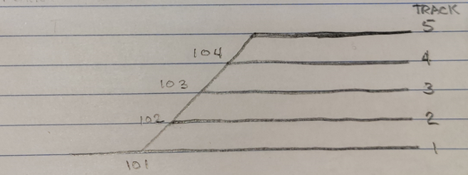
Track 1: Main
Step 1: Sketch the track schematic to be controlled by the macro.
Step 2: List all of the switch machine addresses (i.e. turnouts) to be controlled by the macro. Turnout addresses 101 102 103 104
Step 3: In order to access track #5 from the Main, list each turnout alignment necessary to get to track 5. In this case turnout 101 will be aligned to the diverging (reverse) route, place the letter R under turnout address 101.
Turnout addresses 101 102 103 104
Alignment thru turnout R
Step 4 : Turnout address 102 must be set for the N normal path. Place the letter N under address 102.
Turnout addresses 101 102 103 104
Alignment thru turnout R N

Step 5: Turnout address 103 must be set for the N normal path. Place the letter N under address 103.
Turnout addresses 101 102 103 104
Alignment thru turnout R N N

Step 6: Turnout address 104 must be set for the N normal path. Place the letter N under address 104.
Turnout addresses 101 102 103 104
Alignment thru turnout R N N N We now have the list of turnout alignments and can configure the macro.
Step 7: The Macro will need to be assigned a number. For this example we will name the macro #15. The NCE system allows macros to be assigned a number from 0 to 15. For this example we will name the macro #15.
Follow the remaining screen steps using your NCE Power Cab or Pro Cab.
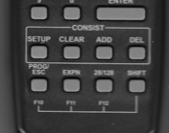 Press the Prog/ESC button multiple times to get to the main screen.
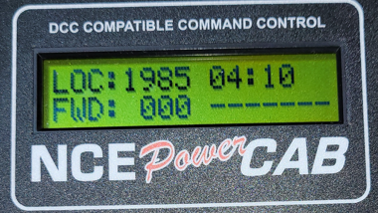 Main or Normal display screen.
Press and release the Prog/ Esc button until you reach the Program Macros Screen.
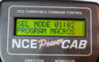 Program Macros Screen appears.
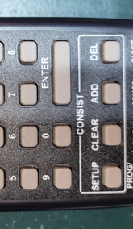 Press the Enter button.
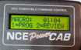 Press 1 to enter the macro programming mode.
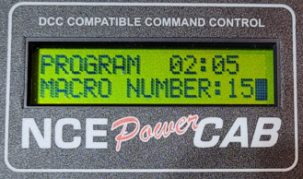 For this example, we will assign this Macro number 15. Press 1 then 5.
Press enter.
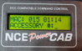 Enter the address of the turnout you want to control. In this case Press 1, then 0, then 1.
Press enters.
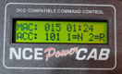 Select the direction for turnout 101. In this case, Press 2 for Diverging (Reverse) route.
Turnout addresses 101 102 103 104
Alignment thru turnout R N N N

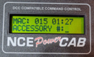 Enter the address of the turnout you want to control. In this case Press 1, then 0, then 2.
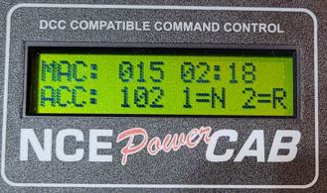 Select the direction for turnout 102. In this case, Press 1 for Normal route.
Turnout addresses 101 102 103 104
Alignment thru turnout R N N N

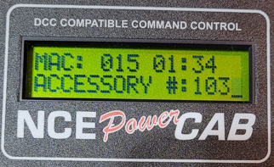 Enter the address of the turnout you want to control. In this case Press 1, then 0, then 3.
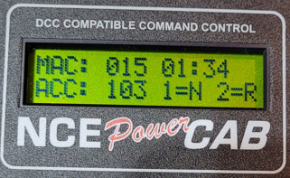 Select the direction for turnout 103. In this case Press 1 for Normal route.
Turnout addresses 101 102 103 104
Alignment thru turnout R N N N
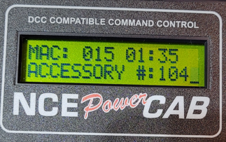 Enter the address of the turnout you want to control. In this case Press 1, then 0, then 4.
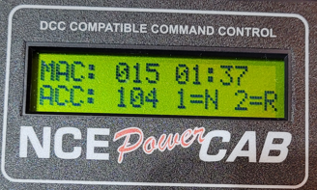 Select the direction of turnout 104. In this case Press 1 for Normal route.
Turnout addresses 101 102 103 104
Alignment thru turnout R N N N
The display will ask for another accessory number. There are no more entries, so just press the PROG/ESC button.
This completes the macro instruction entry.
End of MACRO instruction entry

How to Review the Macro commands you have entered
Start from the Main screen.
Press and release the Prog/ Esc button 7 times until you see the Program Macros Screen.
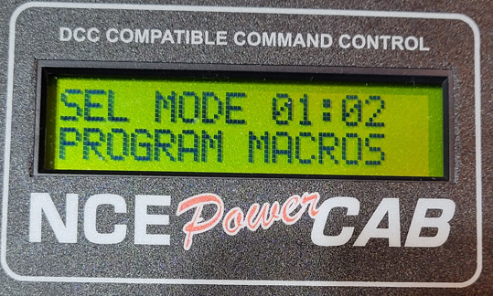 Program Macros screen
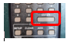 Press Enter
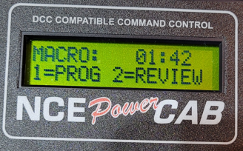 Press 2 to review the Macro commands.
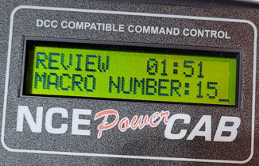 Enter the Macro number, in this example Press 1, then 5.
Press Enter
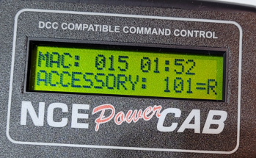 This display says you configured Switch Machine 101 for Diverging (Reverse) Route.
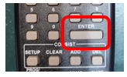 Press Enter.
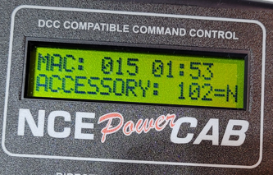 You have configured Switch Machine 102 for Normal Route.
Press Enter.
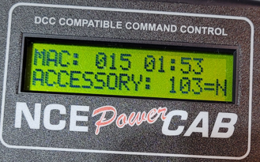 You have configured Switch Machine 103 for Normal Route.
Press Enter.
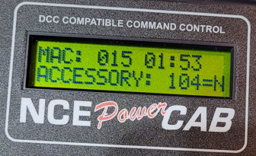 You have configured Switch Machine 104 for Normal Route.
Press Enter.
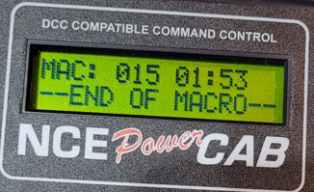 Macro is ready to use. Press Prog/ESC, two times to get back to “Main screen”.
Main screen.

End of Macro review

HOW TO INITIATE A MACRO ON YOUR LAYOUT
Start at the Main screen.
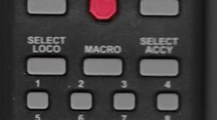 Press the MACRO button.
Enter the desired macro number, in this example Press 1, then 5.
The Macro commands will be sent to the Switch IT board. Each turnout address that was entered into the macro will align the turnout to the N normal or R reverse/diverging route. In this example track 5 can now be accessed via the yard ladder.

Disable SWITCH IT 2 Pushbuttons from controlling switch machines.
The Switch IT-2 circuit board has an optional set of input terminals that allow you to control a turnout via pushbuttons as well as with the Select Accessory function from your cab throttle.
In this example I have pair of Switch-IT-2 circuit boards. The factory default state of a Switch IT board is enabled to allow pushbutton operation. This means that Configuration Variable CV 556 = 0 (enable Push button control).
The following example will show you how to disable the push buttons associated with a specific Switch IT board.
From the main screen
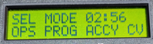 Press and release the Prog/Esc button until you get to the OPS PROG ACCY CV screen.
Press Enter
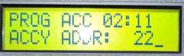 Ignore any numbers that are displayed.

NOTE: Switch IT board #2 has two outputs A and B. In this example (and in the video) output A is associated with address 104 which controls the switch machine. Output B controls its switch machine with address 103.
I want to disable the push buttons that are associated with Switch It board # 2. To do this we will use Configuration variable CV 556 and we need to know what switch machine address is associated with Output 1 only. The address value can be read by pressing the SELECT OUTPUT button on the Switch IT. The LED above Output 1 will turn on and the seven segment display will cycle thru the address one digit at a time. So the display will show 1 0 4. In other words, “Output 1 has been assigned address 104”. Setting CV556 to a value of 1 will disable the push buttons for both switch machines 103 and 104.
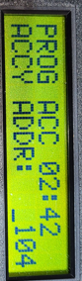 From this screen Press 1, 0 , 4
Press Enter
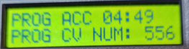 Press 5, 5, 6
Press Enter
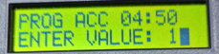 Enter value Press 1 This value will disable the push button inputs.
Press Enter
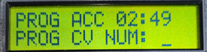 The display now switches to this screen, there is nothing to be entered here. 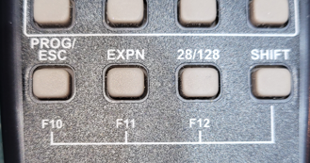 PRESS Prog /Esc button.
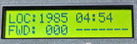 Returns you to the main screen.
Now try using the push buttons associated with Switch IT board #2. They are disabled, switch machines 103 and 104 will not operate via the push buttons. Next, we will verify that the Cab throttle can still activate the turnouts.
Press SELECT ACC button.
Press 1 0 4
Press Enter
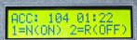 Select the path thru the turn out that you want the switch machine to change to. Press 1 for N Normal or 2 for Diverging -Reverse route.
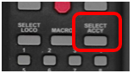 Press SELECT ACC button.

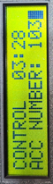 Press 1 0 3
Press Enter.

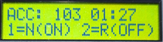 Select the path thru the turn out that you want the switch machine to change to. Press 1 for N Normal or 2 for Diverging -Reverse route.
The display will now return to the main screen.

How to enable the Push Buttons for a Switch IT 2 board
From the main screen
Press and release the Prog/Esc button until you get to the OPS PROG ACCY CV screen Press Enter
NOTE: Switch IT board #2 has two outputs A and B. In this example (and in the video) output A is associated with address 104 which controls the switch machine. Output B controls its switch machine with address 103.
I want to ENABLE the push buttons that are associated with Switch It2 board # 2. To do this we will use Configuration variable CV 556 and we need to know what switch machine address is associated with Output 1 only. The address value can be read by pressing the SELECT OUTPUT button on the Switch IT. The LED above Output 1 will turn on and the seven segment display will cycle thru the address one digit at a time. So the display will show 1 0 4. In other words, “Output 1 has been assigned address 104”. Setting CV556 to a value of 0 will ENABLE the push buttons for both switch machines 103 and 104.
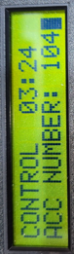 From this screen Press 1, 0, 4
Press Enter
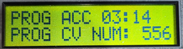 Press 5, 5, 6
Press Enter
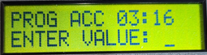 Press 0, This will enable the pushbuttons.
Press Enter
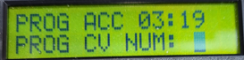 The display now switches to this screen, there is nothing to be entered here.
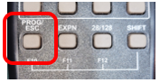 PRESS Prog /Esc button.
Display returns to the main screen.
Now try using the push buttons associated with Switch IT board #2. They are enabled, switch machines 103 and 104 operate.
Now confirm that you can control the turnouts with your cab throttle.
Press SELECT ACC button.
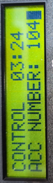 Press 1 0 4
Press Enter.
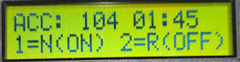 Select the path thru the turn out that you want the switch machine to change to. Press 1 for N Normal or 2 for Diverging -Reverse route.
The display now returns to the main screen.

Press SELECT ACC button.
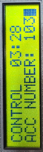 Press 1 0 3
Press Enter.
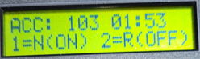 Select the path thru the turn out that you want the switch machine to change to. Press 1 for N Normal or 2 for Diverging -Reverse route.
Press enter.
the display returns to main screen.

.

How to disable Push buttons connected to a Switch It 8 button board
In the previous examples we have been using the SWITCH IT 2. This example is the SWITCH IT 8 is being used with the demo board. The Switch IT8 has eight outputs. In order to disable or enable the push buttons associated with the button board connected to the Switch IT 8 we need to know the address of Output 1 of the Switch it, even if you do not use output 1, you still need that address.
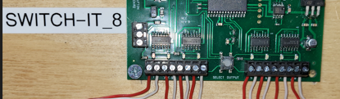 On the Switch IT8 Board press the Select Output button. The LED associated with Output 1 will turn on.
Output 1 LED

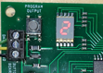 Observe the seven segment display , it will display the address that is currently associated with OUTPUT 1. In my demo set up the address is 22. It could be any number from 0 -2044. A brand new SWITCH IT8 board has a default address of 1.
Now using the Cab throttle .
Start from the Main screen.

Press and release the Prog/ESC button until you get to OPS PROG ACCY CV screen.
Press enter.
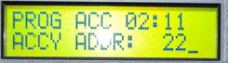 Press 2 2 this is the address associated with Output 1 of the Switch IT 8 board.
Press Enter.
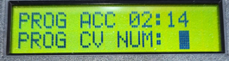 Press 5 5 6
Press Enter.
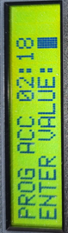 Press 1. CV_556 is now equal to 1 . This will DISABLE all eight of the button board push buttons .

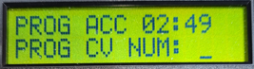 The display now switches to this screen, there is nothing to be entered here.
Press PROG/ESC button.
Display returns to Main screen.

Confirm that the push buttons connected to the Button board inputs are disabled.
Confirm that you can still control the turnouts connected to the SWITCH IT 8 outputs using the Cab throttle.

How to enable Push buttons when connected to a Switch It 8 button board
In the previous examples we have been using the SWITCH IT 2. This example is the SWITCH IT 8 is being used with the demo board. The Switch IT8 has eight outputs. In order to disable or enable the push buttons associated with the button board connected to the Switch IT 8 we need to know the address of Output 1 of the Switch it, even if you do not use output 1, you still need that address.
On the Switch IT8 Board press the Select Output button. The LED associated with Output 1 will turn on.
Output 1 LED

Observe the seven segment display , it will show the address that is currently associated with OUTPUT 1. In my demo set up the address is 22. It could be any number from 0 -2044. A brand new SWITCH IT8 board has a default address of 1.
Now using the Cab throttle .
Start from the Main screen.

Press and release the Prog/ESC button until you get to OPS PROG ACCY CV screen.
Press enter.
Press 2 2 this is the address associated with Output 1 of the Switch IT 8 board.
Press Enter.
Press 5 5 6
Press Enter.
Press 0. CV_556 is now equal to 0 . This will ENABLE all eight of the button board push buttons .

The display now switches to this screen, there is nothing to be entered here.
Press PROG/ESC button.
Display returns to Main screen.

Confirm that the push buttons connected to the Button board inputs will activate the switch machines that are connected to the SWITCH IT 8 outputs.
Confirm that you can still control the turnouts connected to the SWITCH IT 8 outputs using the Cab throttle.

END OF PRESENTATION step by step instructions.

