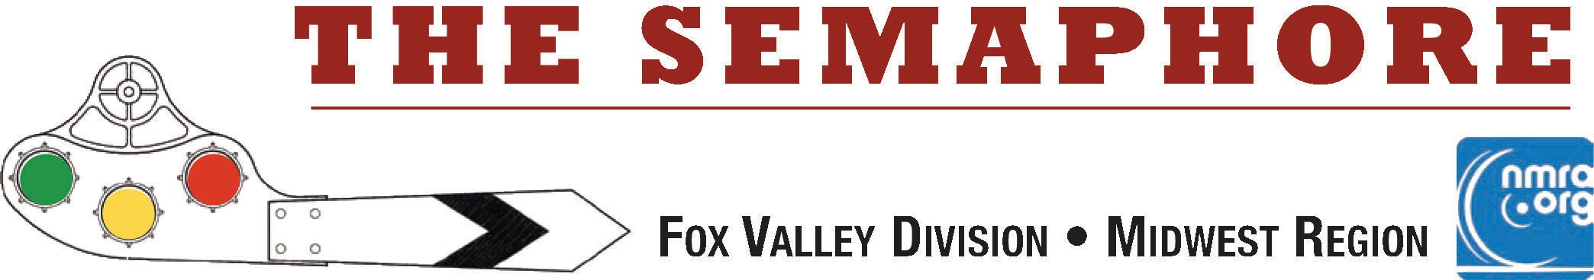

May 2023

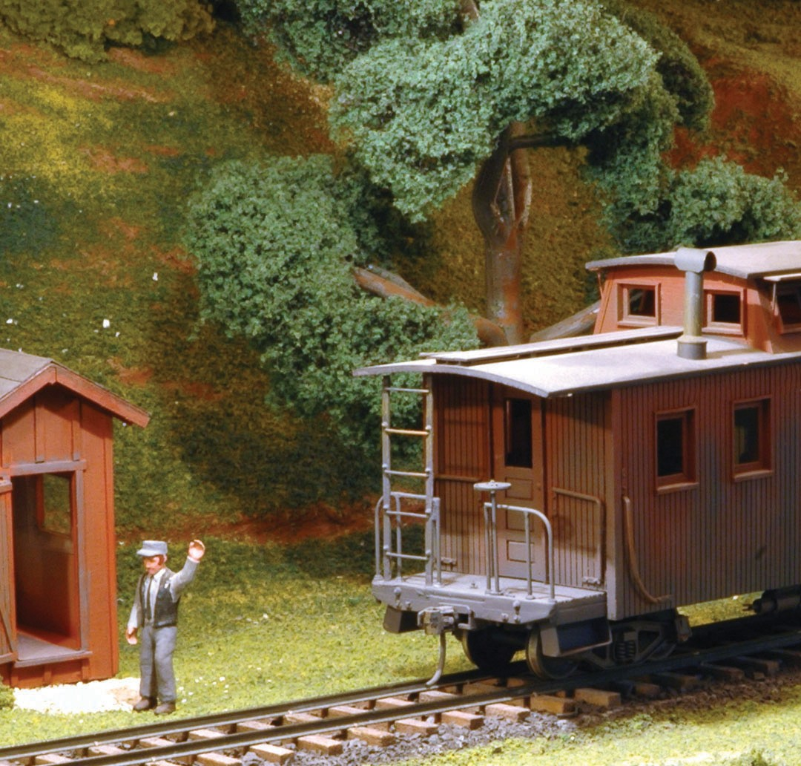I thought it fitting to cover this issue with photo I took of FVD MMR® David Crement's very detailed and accurate On30 East Broad Top railroad a number of years back. Here, the EBT tunnel door minder bids adieu to the crew of the passing train.

Jim Osborn, MMR®, Editor

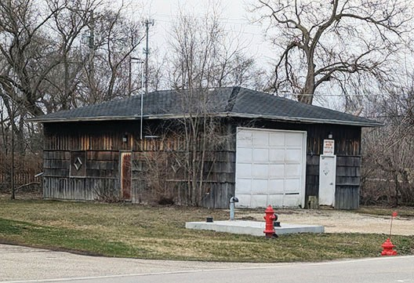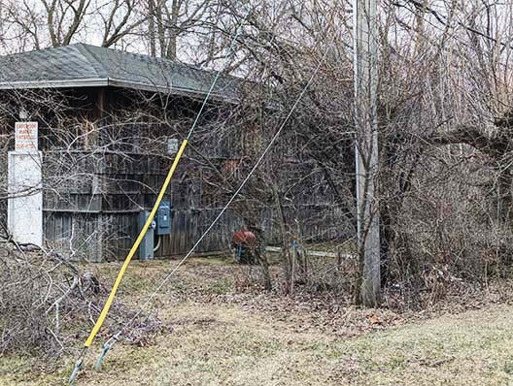Keep those Trains Moving by Jim Osborn, MMR®...
In This Issue...
Page 1
Page 2
Page 2-4
Page 4-7
Page 7
Page 8-9
Page 10
Page 11
Page 12
Adios!
Keep those trains moving
Chicago Industrial Traffic Plan Fun Stuff: The Missabe Jct. RR Mike's Minute
FVD Annual Meeting Minutes Contest Results & Next Meet What's Happening (or not) Division Information
There is nothing like a live and in-person clinic to get the modeling juices flowing! John Drozdak reminded us about that feeling at the April meet. His clinic on weathering with PanPastels® was very instructional and inspirational. We thank John for a great presentation.

Next month we will have another live and in-person clinic. David Lull will be with us to cover the History of Cardboard Structures. I used to turn my back away on cardboard structures, until I saw a clinic on them at a Rock River Valley Division meet that blew me away. Enhancing a cardboard structure with multiple layers of various relief items changes the structure from a simple photo to a decent building. They are not the answer for every structure you need, but when done correctly, they can very nicely and economically serve certain scenery requirements.

Speaking of structures, I saw an interesting building about a mile from my home. It's a local, water, co-op building housing the well and treatment infrastructure for a number of houses in the area. If you are into scratch building, here is a prototype with real character.

The three sides of the heavily weathered building are shown. There are plenty of antennas, pipes, poles, fixtures and paraphernalia on this building to make a really interesting structure. It's a scene to have some fun with. Send me an email if you want larger photos and measurements.

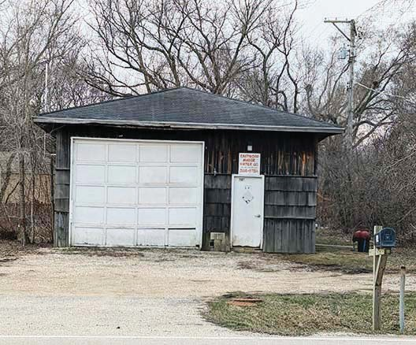
On the topic of scratch building, the world wide web is obviously a great source of pictures & plans. One super source is the Library of Congress. They have millions of historic photos & plans. Check out their site and search to your heart's content: https://www.loc.gov/pictures/

* * *

As I announced at the Annual Business meeting, this will be my last issue of the Semaphore as the Editor-in-Chief. I volunteered to temporarily take on the assignment after the unexpected passing of Walt Herrick several years ago. I feel the Semaphore is an important communications tool for the division, so I raised my hand to help out. After 25 issues, it is time to step aside and hand the blue pen over to another Fox Valley Division member.

Happily I can announce that Chris Mattimiro has volunteered to step into the Publications Trainmaster position. Chris is relatively new to the division, but he is well-equipped to handle the job. If you have not met him, Chris was pictured in the Christmas cover photo of the February issue of the Semaphore.

I hoped you enjoyed the newsletter over the recent span of issues. I want to thank Mike Hirvela, Rich Sieben, and Keith Dart for their support with content and proof reading skills. Their help was critical to producing a good product.

The Semaphore will take on a new look, feel and frequency with the change - that's the editor's & BoD's prerogative. But, whatever the format is, content is essential for its success and continuation. Please take a minute to share your modeling content, photos and stories with Chris to help him keep the newsletter on track. Send your content through our "Contact Us" web page via the Publications Trainmaster. It will go directly to Chris.

https://www.foxvalleydivision.org/fvd2016/contactus.v2.html

Take care; stay safe, And Keep Those Trains Moving!
Jim Osborn, MMR®, Editor

Richard Sieben is a regular contributor to the Semaphore. This month he explains the traffic plan and car routing system he developed for his N scale Chicago Industrial Terminal railroad.
I didn’t want the switching job to simply be "spot everything you bring and pick up everything that is there" type of switch order. To solve this, I use turn numbers, or if I have over 7 operators, we use a real time clock. When a car is spotted, the turn number or hour number (24-hour clock) is written in the ‘tm’ blank space on the car card. Once a car is spotted at its destination, it has to stay on spot for 2 hours - or turns - before it can be moved. There are 18 moves printed on each card; this eliminates the repeated back and forth of the same cars hitting the same spot session after session.

Destinations for each car move are determined by the car type and what types of cars can go to each industry siding. The destinations for any one car are selected at random with alternate moves going to some randomly selected interchange tracks. I used an Excel spreadsheet to do this work.

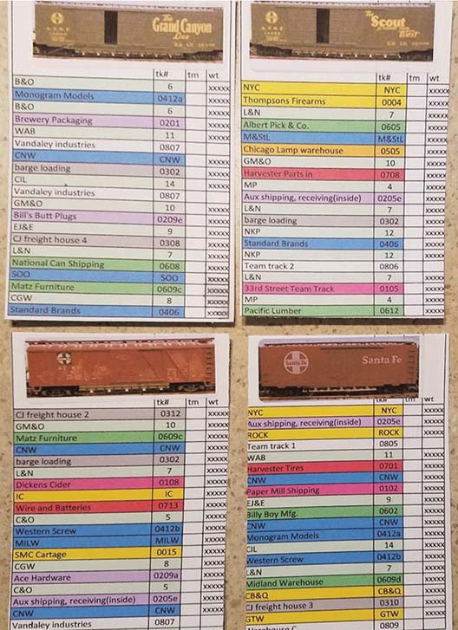
The turn jobs are developed so that traffic does not bunch up at a location and a car is considered en-route until it is properly spotted at the destination. This allows for off- spotting cars if there are too many for a siding.

* * *
Traffic Plan for the CIT by Richard Sieben

What I don’t like about most car cards and waybill operations is that there is no picture of the car, just its car numbers. So the first requirement was to have a car card big enough to have an easily recognizable picture on it. In addition, traditional waybills often list names of destinations that are off of the railroad. For a new operator, it is hard to know where a car for ‘St. Louis’ is going on the layout.

My solution is to color code the layout by switch job and have all ‘off layout’ locations be interchanges with other railroads. In general, cars go from an industry to some interchange track and then from the interchange to another industry. In special situations, I have 2 industries on the layout, sending cars back and forth to one another other. Every now and then, one car gets pulled out at random to go to a car shop for repairs. The car cards are color coded so that yard crews can sort trains by color; switch crews use the description and a zone & track number combination to know where the car is to be spotted.

Four 3x5 inch car cards with pictures, routing order and spot time boxes are shown above.

I wanted the traffic plan for my layout to split work up evenly between crews. Through experience I found it takes an average of 1 minute per car processed. This includes the time it takes to understand where the car is going, to make the switching moves and to record the time the car was spotted.

Each switch job is designed to take 15 to 20 minutes to spot cars and another 15 to 20 minutes to make your pickups. I found that 10 to 15 sidings are enough to make a ‘job.’ The
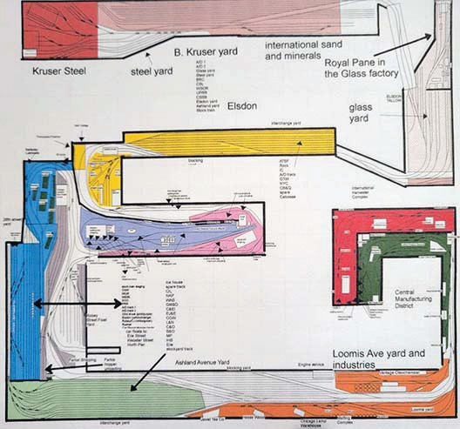
colors on the layout plan indicate the switch job.
The CIT Layout Plan is shown above.

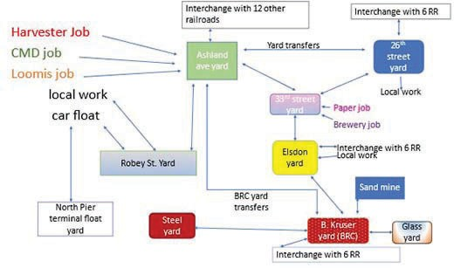
Transit to and from the local yard can eat up another 10 to 15 minutes: waiting for a spot in the yard, negotiating around other jobs, etc. Built into the total time is another 15 minutes to take a break, get a drink or snack or to kibitz

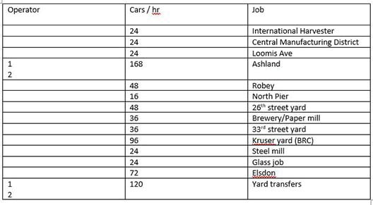
The list of jobs and relative traffic is shown below:
Jobs on the CIT are assigned by skill level and/or by where work needs to be done next. When operating with less than a full crew of 16, there is some form of jumping from job to job. For example, the Robey job could be assigned to turn 4 but the North Pier job may be at turn 3. The Robey operator could do the North Pier job after all the Robey moves are completed.

The layout can accommodate 1 to 16 operators, visitors are welcome. Mark up at www.operatingsessions.com for the Chicago Industrial Railroad. Regular sessions are the second Saturday of every month at 1pm. Special sessions can be called if there is enough interest.

Rich Sieben, FVD

Fun Stuff by Jim Osborn, MMR®...

I recently attended an operating session hosted by Steve Miazga, MMR® and member of the WISE Division. Steve's Missabe Junction N Scale Railroad is always fun. The scenic setting of the outstanding Missabe Jct. RR is northern Wisconsin. The following pictures speak for themselves. I would like share a few snaps of Steve's creations which I took at the session in between jobs.

with friends.

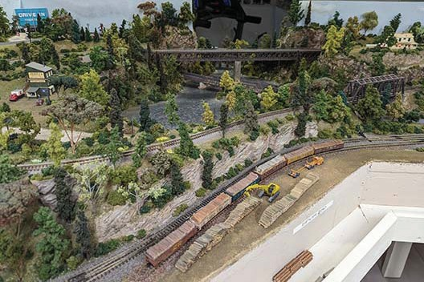
The traffic flows are mapped out above.

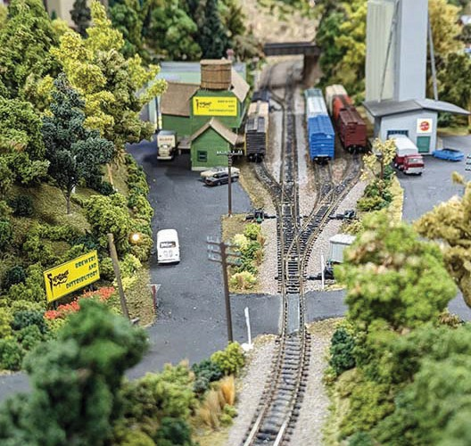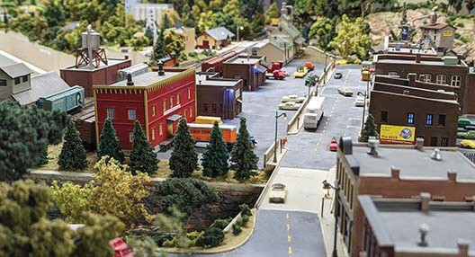

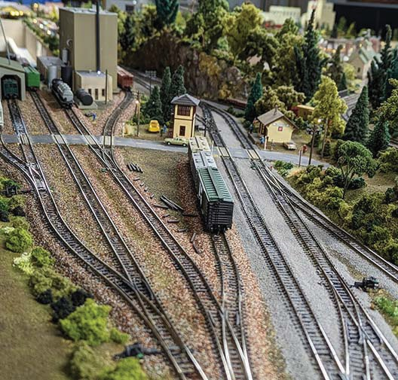
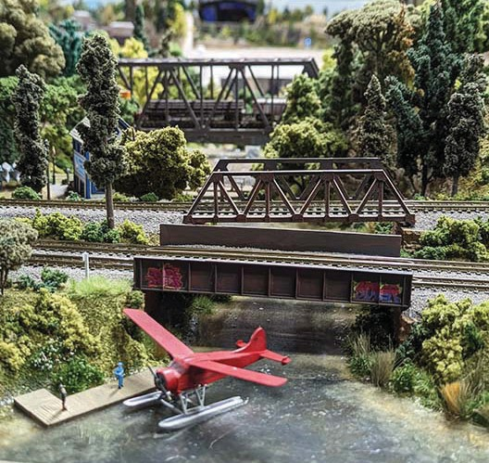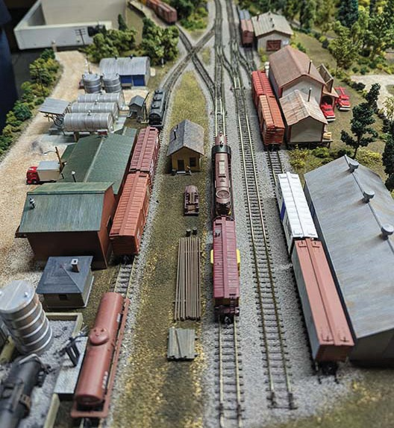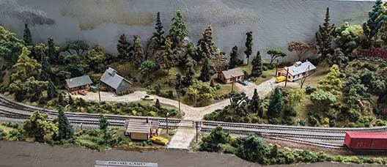Check out the amazing detail Steve has incorporated into this Pike. The entire layout is built on foam board. That makes for easy terrain creation or modification as required. This is a must-see layout. Steve has recently completed the Oneida addition with a paper plant at the south end of the railroad. It is a very challenging switching puzzle! (continued >>)

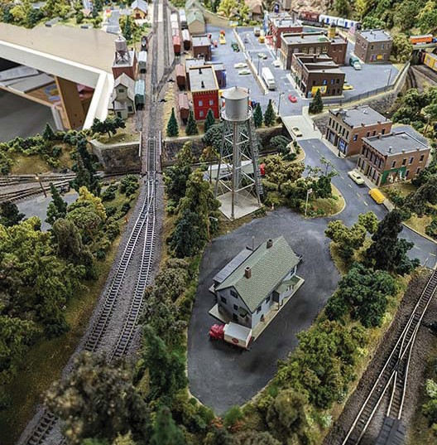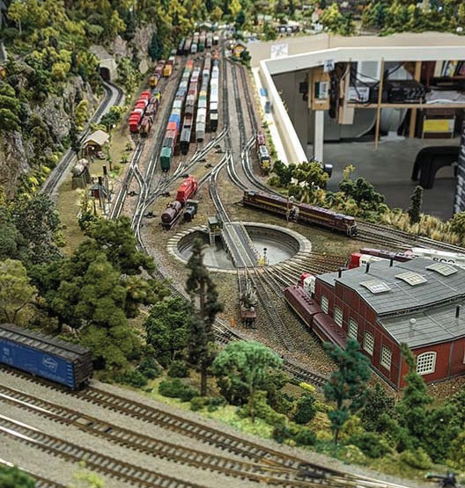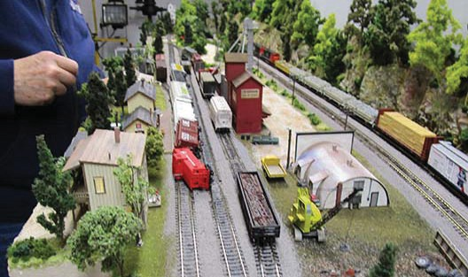
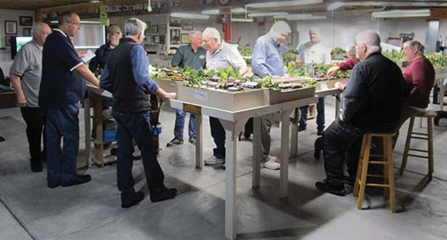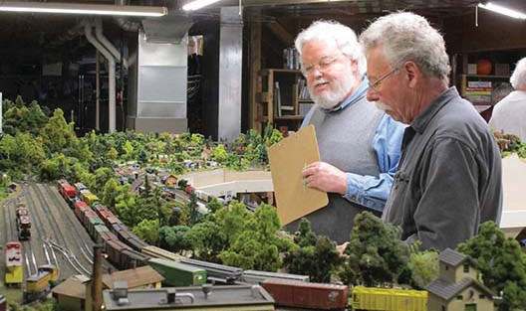
A couple of shots of the operators at the session. Steve can accommodate a crew of up to 16 at a normal session.
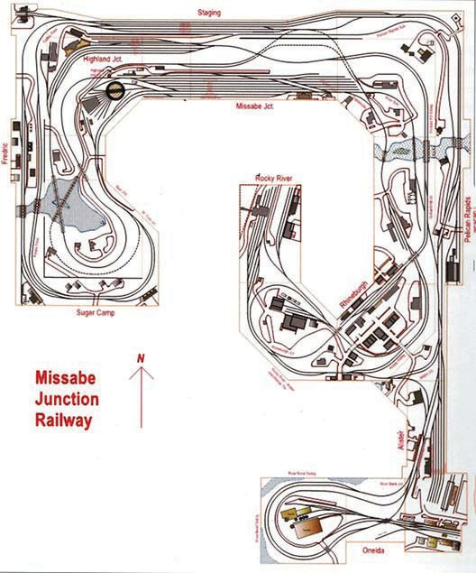
On the left, you can see that derailments don't just 'happen' on the Norfolk Southern. Uncoupling N scale cars can often create collateral damage if you're not careful. Steve's track work is generally not at fault. (continued >>)

Fun Stuff... continued.

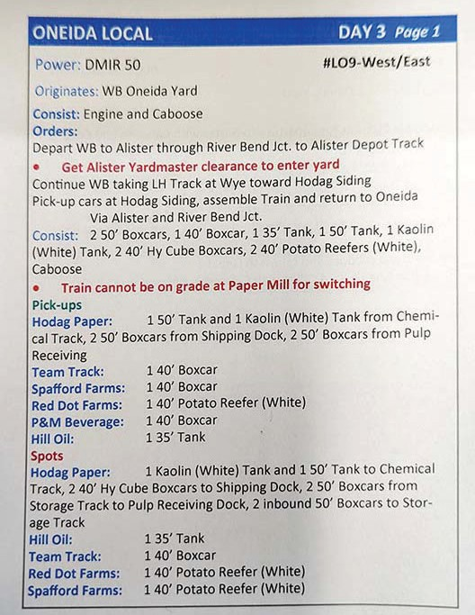
Above is a typical train order for the various crews. It outlines the work to be performed on a particular run.
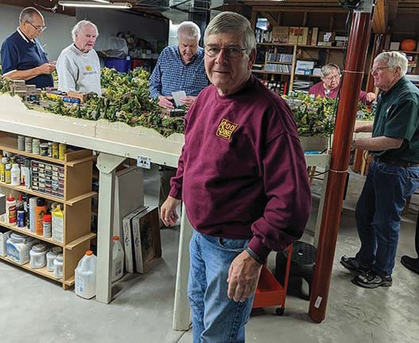
Steve Miazga takes a pause from his dispatching and troubleshooting activities to pose for the camera. Steve's railroad is a masterpiece and a testament to his modeling skills. Contact the editor if you would like to arrange a visit to this railroad in Waukesha, WI. Model railroading is FUN!
Jim Osborn, MMR.®

Mike's Minute ...
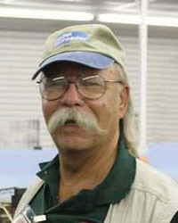
This past April 16th , we had our Annual Meeting of the Members, as required by our By-Laws combined with our regular monthly meeting. The Annual Meeting included introductions of and reports by the members of the Board of Directors and Trainmasters, plus the election of an Assistant Superintendent and a new
Paymaster. Denis Zamirowski was re-elected as Assistant Superintendent and Rich Sieben was elected Paymaster, replacing the retiring Tim Kleimeyer. The division whole- heartedly thanks Tim for his 18 years of dedicated service as Paymaster and other years serving as division official in various capacities. I know Rich will be actively working to fill those Paymaster shoes. The complete minutes of the meeting follow on page 8.

Our regular meeting agenda included Division, Region, and National NMRA news along with railroad model announcements and latest model releases. We also share news of what’s happening on the Prototype railroads and at Railroad Museums. If you weren’t in attendance either in person or over the net, you missed a cornucopia of railroad information. Our feature presenter was our own John Drozdak, who demonstrated his weathering techniques using pan pastel pigments on freight cars and structures. We used a second video camera on his work area for close- up viewing.

The next division meeting is on May 21st and is our last meeting for our 2022-2023 season. It has been a technologically challenging year and I’m looking forward to what is next. Traditionally, we’re off for the summer after the May 21st meeting and hopefully will be enjoying the summer visiting train places here and there. We reconvene on September 17, 2023, for our 2023-2024 season.

Finally, I would like to remind you that our FVD meeting notices come out via e-mail about a week before our meeting date, so please be sure we have your current e-mail address. Our webmaster sends out the meeting notice with the ZOOM system log-on credentials to make it easy to use the Zoom system if you’d rather participate that way. Whichever method you select to participate, I appreciate your taking the time and effort to attend.

You can see the full schedule, clinics and contest topics at:
https://www.foxvalleydivision.org/fvd2016/timetable.v2.html I hope everyone has a great summer of train watching. Regards, Mike Hirvela, Superintendent

PRELIMINARY MINUTES OF THE ANNUAL MEETING OF THE MEMBERS, APRIL 16, 2023, FOX VALLEY DIVISION (FVD), MWR, NMRA

CALL TO ORDER
The Annual Meeting of the Members of the Fox Valley Division, NMRA, was held at the Gary Morava Recreation Center, 110 West Camp McDonald Road, Prospect Heights, Illinois 60070 and the meeting was also hosted via Zoom Video Conference. The meet- ing was called to order at 1:01 pm by Superintendent Mike Hirvela who presided over the meeting. The Chief Clerk, Rich Hoker, recorded the minutes.
Others Board members attending were: Asst. Superintendent Denis Zamirowski, Paymaster Tim Kleimeyer, Programs and Clinics Trainmaster Gary Saxton, Contest and Achievement Program Trainmaster Jim Landwehr, Publications and Webmaster Trainmaster Jim Osborn, and Public Affairs Trainmaster Keith Dart. Membership Trainmaster Erich Abens respectfully notified the Superinten- dent he was unable to attend.
Members: The Annual Meeting date and time had been announced and posted in advance on the FVD website and communicat- ed to the membership at prior FVD regular meetings and in Division publications. There were approximately 25 attendees in the meeting, which included members at the Morava Center and others connected via Zoom. The Zoom conference for both audio and video were operating properly. The Superintendent noted that a quorum was present and declared the meeting as valid to conduct FVD business.

BOARD MEMBER REPORTS:

SUPERINTENDENT
Mike Hirvela welcomed everyone, provided an overview of the topics for the Annual Meeting and a brief summary of the FVD ac- tivities and status over the year. The Superintendent noted that during the year the meetings were presented with good success, there were quality clinics, and good discussions. The Superintendent introduced each of the Board members who provided their report as follows:
ASSISTANT SUPERINTENDENT
Denis Zamirowski presented the Assistant Superintendent’s report and commented on the food and beverage service and the Snack Fund for monthly meetings, including explaining that food and beverages are paid with contributions from members. CHIEF CLERK
The Chief Clerk took minutes of the meetings and noted that eight meetings of the Board were conducted during the year with good Board representation at each meeting. One of the main focuses of the Board during the year was the ability to provide virtu- al Zoom connections to the live meetings. The Board had invested a significant amount of time and also purchased equipment to facilitate the virtual component of the meetings.
PAYMASTER
Tim Kleimeyer provided the Paymaster’s report for the period noting that the financial position of the Division was in good order. The largest expense was the cost of the meeting space for the monthly meetings. Tim was not seeking reelection this year and therefore provided his comments on the prior cost for hosting the annual train show called High Wheeler. The Superintendent noted Tim’s long length of service to the FVD and thanked him.
CLINICS & PROGRAMS
Gary Saxton reported that he had coordinated all of clinics for this season and was starting to recruit clinicians for the 2023/2024 season.
ACHIEVEMENT AWARDS & CONTESTS
Jim Landwehr reported that the Achievement Program and monthly meeting contests had gone well this year. The meeting con- tests are currently being planned for 2023/2024 season and Jim asked the membership if they had any suggestions for changes in the contest program, they should contact him directly.
PUBLIC AFFAIRS, SOCIAL MEDIA
Keith Dart provided the Public Affairs and Social Media report and noted that he had been updating the Division’s Facebook page and had also been assisting with Midwest Region social media activity.
PUBLICATIONS AND WEBMASTER
Jim Osborn provided the Publications and Webmaster report. Jim has assuming the duties of the Publications Trainmaster since that position became vacant. Jim noted that the Semaphore has been published monthly with good content and information. Jim thanked certain members for their contributions over the past couple of years. Jim noted that a new Publications Trainmaster had been identified who would be taking over the Publications Trainmaster role after the May issue of the Semaphore.
With regard to the Webmaster role that Jim also services, Jim noted that the FVD website was up to date and that the website typi- cally has 300-400 visits per month as members look for information. The most popular web pages that are visited are the monthly Semaphore link, listings of model railroad clubs, railroad events and the list of hobby shops.

PREVIOUS MEETING MINUTES
The transcribed minutes of the prior Annual Meeting dated April 24, 2022 were provide to participants at the Morava Center. A Motion to approve the minutes was made by a member and seconded by another member. On a voice vote, the Motion to ap- prove the prior year minutes was past.

NEW BUSINESS
Election of the Assistant Superintendent and Paymaster are conducted in odd numbered years for a 2 year term. Notice of the election of these two positions had been posted in prior FVD meeting materials and discussed at prior FVD meetings. Denis Zamirowski, the incumbent Assistant Superintendent, agreed to rerun for the position of Assistant Superintendent and submitted his name for re-election. Rich Sieben submitted his name for election to the position of Paymaster. No other candidates present- ed themselves prior to the Annual Meeting for the two roles. The background information regarding the election as well as the biographies of Denis Zamirowski and Rich Sieben were included in the March 2023 issue of the Semaphore, which was posted on the FVD website. In the Annual Meeting, the Superintendent asked if there were any other candidates who wished to submit their names for the positions of Assistant Superintendent or Paymaster. No additional candidates presented themselves. The Superin- tendent then received from a member a motion for a unanimous ballot to elect Denis Zamirowski to the position of Assistant Su- perintendent and a second unanimous ballot to elect Rich Sieben to the position of Paymaster. Both motions were seconded by an additional member. No member requested any additional information or objected to the motion. The Superintendent called
a voice vote on the proposal for a unanimous ballot for the two candidates and all members in the room and connected via Zoom agreed with the motions. There were no dissenting votes for either motion. Therefore the motions passed and Denis Zamirowski was elected to the position of Assistant Superintended and Rich Sieben was elected to the position of Paymaster for a period of 2 years.

Meeting dates for the 2023-2024 season were discussed and the Board will consider them at a future meeting.

There was discussion to consider other meeting locations within the division that had been used many years ago, but may have lower fees.

The Superintendent then reviewed upcoming train shows, including one in Franklin Park, Illinois on June 10.

There was additional discussion of the idea of hosting a model railroad show in the future and of hosting a summer outing for the membership.

The attendees were asked if any other discussion matters existed.

ADJOURNMENT
With no further items to discuss, a Motion to adjourn was made by a member and seconded by a separate member. On voice vote, the motion was approved. The meeting was adjourned at 1:25 PM.

Respectfully submitted, Richard Hoker, Chief Clerk, Fox Valley Division of the NMRA

Next Meet - May 21, 2023, 1:30 start. In person at the Gary Morava Center and via Zoom.

Clinic Presentation: The History of Cardboard Structures by Dave Lull Live and in-person!

Check the FVD website Timetable for details and updates as they become available.
https://www.foxvalleydivision.org/fvd2016/timetable.v2.html

The preliminary FVD meeting dates for the next modeling season are listed here. Mark your calendars! 9/17/2023, 10/15/2023, 11/19/2023, 12/17/2023, 1/21/2024, 2/18/2024, 3/17/2024, 4/21/2024, 5/19/2024
Always check the timetable page on the FVD web site for the latest information.

The April contest featured Open Loads
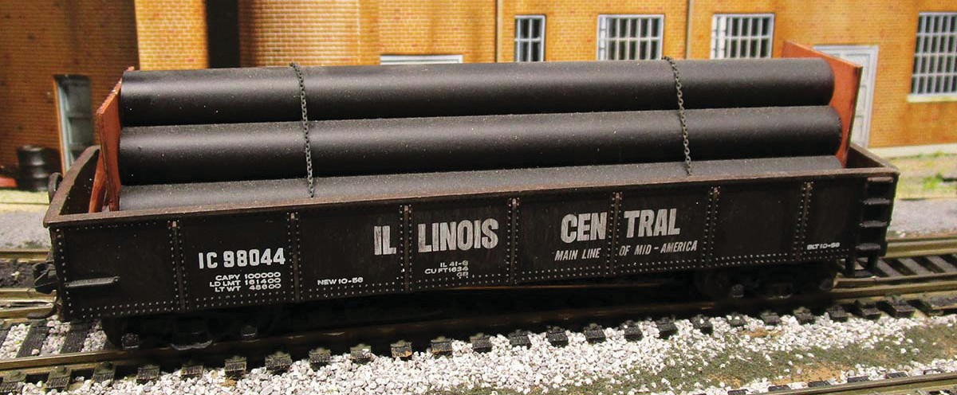
There was only one entry submitted very late - so there was no voting. It was from Mike Hirvela. It is obviously a good looking Gondola with a Pipe Load. Mike tells us that it is an HO Scale kit built car pictured below.

The May Contest Category is Any Structure. Here's a great scratch built structure from the October 2020 meet by Jeff Jarr. Send in up to 3 photos of your RTR, Kit or Scratch built models anytime using our secure upload form: https://form.jotform.com/201995250508962
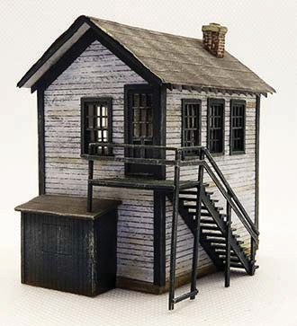
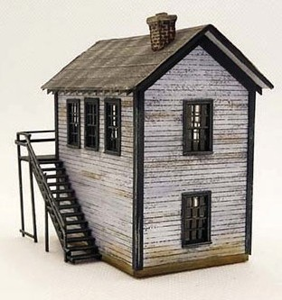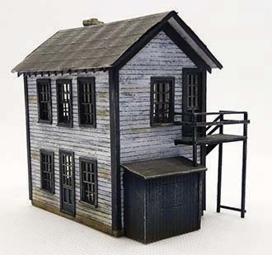

What’s Happening - or not ...

The FVD held its Annual Business Meeting on April 16, 2023. The agenda included the Election of Denis Zamirowski to office of Assistant Superintendent and Rich Sieben to the office of Paymaster.

The Rock River Valley Division will hold a joint meet with the SCWD on May 7th at Paulson's Agriculture Museum of Argyle 6950 Belvidere Rd. Caledonia, IL 61011 1:00 pm - 3:00 pm. The contest is Flatcars - models and pictures.

The Midwest Region of the NMRA will hold its Board of Directors meeting and the Annual Meeting of the Members on May 20, 2023 in conjunction with the Illinois Valley Division meet.

The CNW Historical Society's new archive building will be dedicated this summer 2023
Great Midwest Train Show (aka: the Wheaton / DuPage Swap Meet) at the DuPage County Fairgrounds in Wheaton, IL. The dates for future shows are generally on the 1st Sunday: May 7, June 4, August 6 & September 10. Follow the signs to the fairgrounds entrance. See: https://www.trainshow.com/
The East Broad Top RR in Rockhill, PA is running its #16 Pacific. See: https://eastbroadtop.com/
The Illinois Railroad Museum in Union IL is celebrating their 70th year in existence in 2023. Events are planned all summer long. https://www.irm.org/
David Leider, past FVD member and Midwest Region, Waybill editor has released a new book. It's titled, The Chicago & Western Indiana and Belt Railroad History. Click on the link for information & ordering. https://www.foxvalleydivision.org/fvd2016/imagesfvd2016/events/cwiflyer1.pdf
There will be a RR Swap meet in New Berlin, WI. July 16 & September 24, 2023. There will be no Midwest Region Convention scheduled for 2023.
Rochelle Railroad Park Railroad Days May 21 & 22, 2023.
See: https://www.cityofrochelle.net/event/541-railroad-days.html
Franklin Park Railroad Daze June 10. https://www.villageoffranklinpark.com/events/railroaddaze/
The St. Louis Railroad Prototype Modelers Meet July 28 & 29, 2023. https://www.stlrpm.com/

The 2023 NMRA National Convention - The Texas Express - August 20 - 26, 2023 Gaylord Texan Resort & Convention Center, 1501 Gaylord Trail, Grapevine, TX 76051 https://www.2023texasexpress.com/
The Naperville RPM will once again be held in the Chicago area on October 27 and 28, 2023. The St. Louis RPM meet in Collinsville, IL, will be on July 28-29

The S - Scale fest will be at Georgio's Quality Inn and Suites Conference Center, Orland Park on November 3-5, 2023 see: https://www.nasg.org/Events/FallSFest.php

Canadian Pacific (CP) and Kansas City Southern (KCS) have officially combined to create Canadian Pacific Kansas City (CPKC)

The preliminary FVD meeting dates for the next modeling year are listed here. Mark your calendars!
9/17/2023, 10/15/2023, 11/19/2023, 12/17/2023, 1/21/2024, 2/18/2024, 3/17/2024, 4/21/2024, 5/19/2024

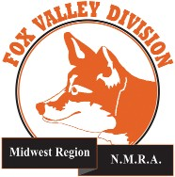
Semaphore Content Wanted ....
Interested in keeping the Semaphore alive? Send us your model or prototype pictures, stories, modeling tips, etc. to share with others in the hobby. Contact the Semaphore editor or any officer at:

http://www.foxvalleydivision.org/fvd2016/contactus.v2.html

About the Fox Valley Division
Superintendent, Mike Hirvela
Fox Valley Division Board of Directors
Asst. Superintendent, Denis Zamirowski Chief Clerk, Richard Hoker
Paymaster, Tim Kleimeyer Achievements & Contests, Jim Landwehr Clinics & Programs, Gary Saxton
Social Media Coordinator, Keith Dart
Semaphore Editor, Jim Osborn, MMR® Ways & Means, Vacant
Membership Services, Erich Abens Membership Promotions, Mike Hirvela Web Technologies, Jim Osborn, MMR® Public Relations, Keith Dart
Need to contact any BoD members? Click this link to:
http://www.foxvalleydivision.org/fvd2016/contactus.v2.html
©Copyright 2022 by the Fox Valley Division of the NMRA, Inc.
If you receive this newsletter, you live in the Midwest Region and Fox Valley Division area of the National Model Railroad Association or NMRA. The Fox Valley Division (FVD) includes all of Lake and McHenry, as well as parts of Cook and Kane Counties in northeast Illinois. About 180 members of varied ages and model- ing ability levels belong to the FVD. Almost all model- ing scales are represented in our division. Subscriptions to the Semaphore newsletters are free. NMRA member- ship in the division is available through the NMRA at:
https://www.nmra.org/
2022 –2023 FVD monthly meetings are held September through May on-line via the ZOOM virtual meeting technology per the schedule in this issue. Each meet- ing features a clinic, model contest, and information of interest to the membership. Outings, layout tours, and operating sessions may also be held when Covid-19 protocols allow gatherings.
We encourage you to take advantage of all the FVD has to offer. We are here to answer your questions, help improve your modeling, and help you better enjoy the great hobby of model railroading. Visit us on the web at: http://www.foxvalleydivision.org/
The Semaphore is published by the Fox Valley Di- vision of the Midwest Region of the NMRA once a month, ten months a year, from September to June.
The Fox Valley Division of the Midwest Region of the NMRA is registered 501(c)7 not-for-profit Illinois corporation.

Mailing address:
Fox Valley Division
P. O. Box 1535
Arlington Heights, IL 60005-1535

Website:
http://www.foxvalleydivision.org/
Regular meetings are held virtually via Zoom and in person at the Gary Morava Center generally from 1:30 until 4:00 PM per the schedule listed in this publication and on its website at:
http://www.foxvalleydivision.org/fvd2016/timetable.v2.html
Editor: Jim Osborn, MMR® Assistant Editor: Michael Hirvela Assistant Editor: Keith Dart Contributing Editor: Rich Sieben
Follow us on Facebook:
https://www.facebook.com/fvdnmra/

