The Semaphore
MONTHLY NEWSLETTER OF THE FOX VALLEY DIVISION, NMRA
O C T O B E R 2 0 2 3

In this issue
Mike’s Minute P.1 Next Meeting P.2
September Contest Winner P.3

Upcoming Events P.3 Contest Calendar P.4 Contact Information P.4

Room with a view, simulated
Train Sim World 4 was released on September 26, featuring new rail services including California’s Metrolink Antelope Valley Line. Driven by an EMD F125, the short car sets feature double-decker passenger cars ending with a Hyundai Rotem cab car (above) controlling the train on the north-to-south route. Look for more on simulators in future issues. Screenshot: Chris Mattimiro

Mike’s Minute
Our 2023-2024 season is underway and if the attendance at the September meeting is any indication, we’ll have a good season. We had 18 folks present at the Glenview Library and another 17 over the ‘net for a total of 35. If you weren’t in on the September meeting, you missed a very good presentation on mining coal in the land of corn and soybeans using some BIG equipment (drag-line shovels with buckets so big you can park two school buses side-by-side in them – made in South Milwaukee), and of course, the railroads to get the coal to market. Side note: The Bucyrus Museum in South Milwaukee is worth a visit as they have some very nice models and real hardware on display. It seemed to me that the presentation showed the State of Illinois south of I-80 is a whole ‘nother world.
We next meet on October 15th at the Morava Rec Center in Prospect Heights. Reason? The next presentation is on state-of-the-art 3-D printing with a live demonstration on-going during the meeting. It is amazing stuff to me, but the detail that can be
obtained using 3-D technology is getting better and better. If you want to see the machine in action and learn about 3-D printing, plan on attending.
October also brings the Chicagoland Railroad Prototype Modelers (RPM) meet which we are co-sponsoring.
This year’s event will be held at Northern Illinois University Conference Room at 1120 E. Diehl Road, Naperville. A Google search will show the location just south of I-88. Registration forms are available on the RPM Chicagoland 2023 website. OK, some folks might find the registration fee a little pricey, but the answer I got back was, “It’s at a University.” Volunteers to be at our booth during the conference would be nice (get in for free). See me at the October meeting.
Last month I noted that if you made a trip this past summer and took lots of photos, we’d love to see them. Our Clinics and Programs Trainmaster Gary Saxton can help you put together a show of Power Point slides from your trip for a future FVD meeting. Such is the case with the November presentation by
Dan Cahill on a trip he made to Ireland. Different, yes, but it is still a flanged wheel on rails.

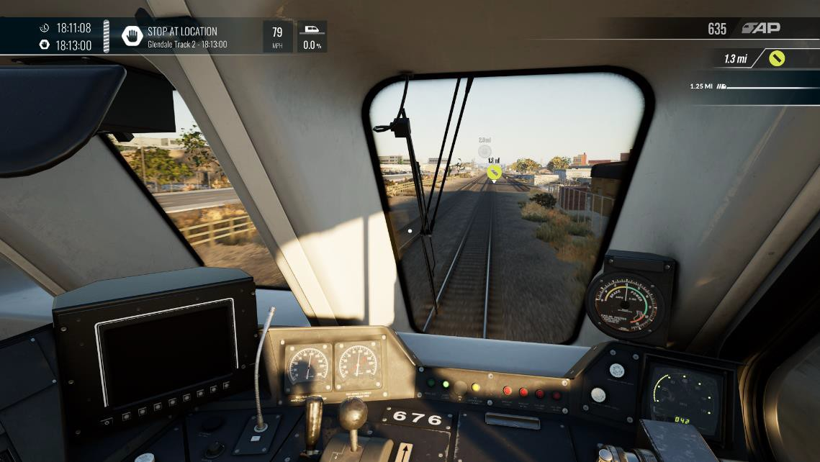
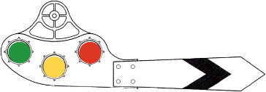

Continued on next page

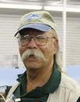
We will then return to the Glenview Library for the December meeting. Why? Well, the GPL is a little closer-in to where most of our members reside and is adjacent to the Metra Line which makes getting to the meeting convenient. We’re trying this location to determine IF it will be an alternative or substitute for the Morava Center for future meetings. Yes, room rental cost is a consideration. We still have the option of participating via Zoom web conferencing as we have obligated to continue to use that system as well. Your input and feedback on the use of these facilities will be of great help in determining where the 2024 meetings will be held. If you are aware of another suitable location, please let a member of the Board of Directors know.
Caption

Mike’s Minute Continued
Prior to our meetings, our webmaster sends out the meeting notice which includes the Zoom log-on credentials to make it easy to use an over-the-computer system if you’d rather participate that way. Whichever method you select to participate, I appreciate you taking the time and effort to attend. Please be sure we have your current e-mail address on file and advise us of any change. Thanks.
Regards, Mike Hirvela

Next Meeting
When: Sunday, October 15, 2023 at 1:30 PM
Where: Gary Morava Recreational Center and Zoom Presentation: Live 3D Printing Demo by Ken Mosny, RRVD Contest: One Repurposed or Retired piece of Rolling Stock

Contest rules: Future contests be held in person at the meet. There will be no photographic entries. All entries will ONLY be displayed at the meet.

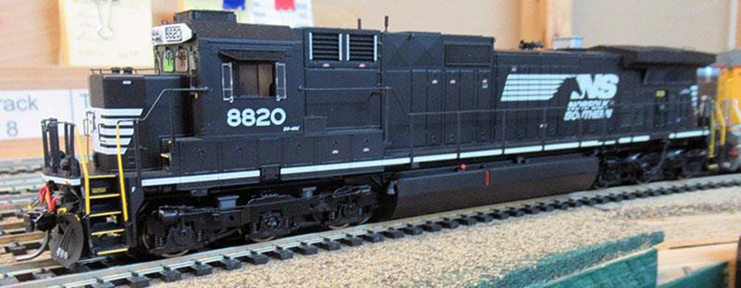
September Contest Winner
Left: Michael Schockley’s “HO Scale – Ready to Run – NS 8-40C” is the winner of the One Diesel Locomotive contest.
Michael Schockley Photo

Upcoming Events

Monthly FVD Meetings
Held the third Sunday of every month at either the Glenview Public Library or the Gary Morava Recreation Center, the meetings are an opportunity to share information, either in-person or on Zoom. Here is the meeting schedule through the end of the year. See the full schedule on the FVD website.
When | Where
10/15/23 1:30-4:00 PM | Gary Morava Recreation center and Zoom
11/19/23 1:30-4:00 PM | Gary Morava Recreation center and Zoom
12/17/23 1:30-4:00 PM | Glenview Public Library and Zoom
1/21/24 1:30-4:00 PM | To be announced

Railroad Prototype Modelers Conference
The RPM Chicagoland Conference returns October 27 and 28 at the NIU Conference Center in Naperville.

Train Shows
Great Midwest Train Shows are held monthly at the DuPage Event Center and Fairgrounds in Wheaton.
Traveling shows will be in Illinois in Springfield on November 11 & 12, and in Collinsville (near St. Louis) on November 25-26. Information on both shows can be found on the Trainshow.com site.
The Central Indiana Division Train Show will be held Saturday, November 18 from 10 AM to 3 PM at the Hendricks County Fairgrounds, west of Indianapolis.

Illinois Railway Museum
Steam Into Fall, October 7. This will be the final public operation of steam trains at IRM for the year.

Fall S-Fest
The Chicagoland Association of S Gaugers is holding a weekend of S gauge model railroading activities at Georgio’s Banquets Quality Inn & Suites Conference Centre in Orland Park November 3-4

Contest Calendar

Division Meeting Date | Contest
October 15 | One Repurposed or Retired Rolling Stock
November 19 | One Illuminated Structure
December 17 | One Steam or Diesel Yard Switcher
January 21, 2024 | One Caboose
February 18 | One Weathered Car or Structure
March 17 | One Steam Locomotive
April 21 | One Refrigerated Billboard Car
May 19 | One Freight Car with an Open Load

About the Semaphore

The Semaphore is published by the Fox Valley Division of the Midwest Region of the NMRA, a registered 501(c)(7) not-for-profit Illinois corporation.
 |  | About the Fox Valley Division
 |  | Board of Directors
 |  | Superintendent: Michael Hirvela  Asst. Superintendent: Denis Zamirowski  Paymaster: Richard Sieben Chief Clerk: Richard Hoker Achievements & Contests: Jim  Landwehr  Clinics & Programs: Gary Saxton |  | Membership Promotions: Michael Hirvela  Membership Services: Erich Abens  Public Relations & Social Media: Keith Dart  Webmaster: Jim Osborn, MMR®  Semaphore Editor: Chris Mattimiro Contact any BoD member here.
 |  | If you receive this newsletter you live in the Midwest Region, Fox Valley Division of the National Model Railroad Association (NMRA). The Fox Valley Division (FVD) includes all of Lake and McHenry, as well as parts of Cook and Kane Counties in northeast Illinois. About 180 members of varied ages and modeling ability belong to the FVD. Most modeling scales are represented in our division.  Subscriptions to the Semaphore newsletters are free. Membership in the division is available through the NMRA at: https://www.nmra.org/  Monthly FVD meetings run September through May in-person and online via Zoom. Each meeting features a clinic, model contest, and |  | information of interest to the membership. Outings, layout tours, and operating sessions may also be held.  We encourage you to take advantage of all the FVD has to offer. We are here to answer your questions, help improve your modeling, and help you better enjoy the great hobby of model railroading. Visit us on the web!  Mailing Address:  Fox Valley Division PO Box 1535  Arlington Heights IL 60005-1535  Website:  https://foxvalleydivision.org/  Facebook:  https://www.facebook.com/fvdnmra/

Staff:
Editor: Chris Mattimiro Assistant Editor: Michael Hirvela Assistant Editor: Jim Osborn
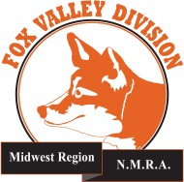
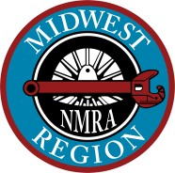

© 2023 by the Fox Valley Division of the NMRA, Inc.

