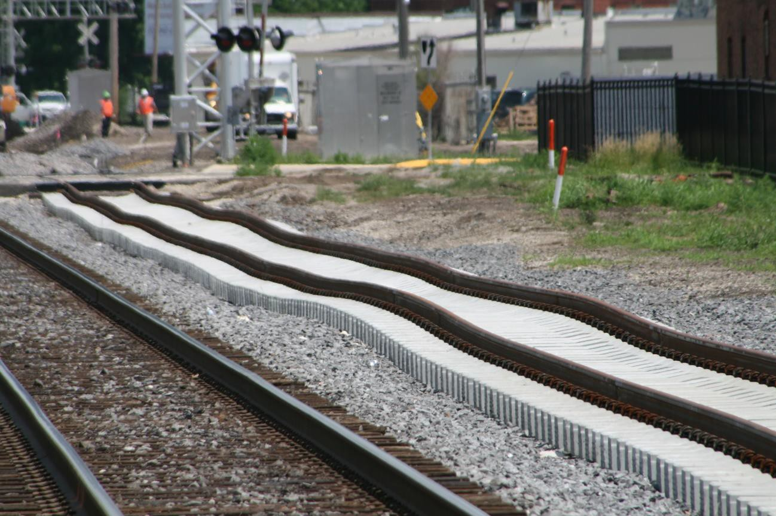
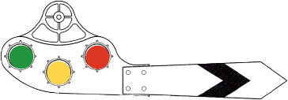
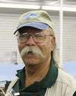
MONTHLY NEWSLETTER OF THE FOX VALLEY DIVISION, NMRA
The Semaphore
D E C E M B E R 2 0 2 3

In this issue
Mike’s Minute P.1 Next FVD Meeting P.2
New Member Welcome P.2 Upcoming Events P.3 Contest Calendar P.4 Contact Information P.4

Not rated for high speed
Dave Nelson’s clinic, “A Closer Look at Track” will examine the parts of a prototype railway, with the goal of making us more aware of the details that should be modeled on our layouts. Join us on Sunday, December 17 at 2 PM at the Glenview Public Library to see Dave’s presentation.

Just saying ‘December’ brings a chill and a shiver to me as it seems it is all too soon arriving, even though we had snow on Halloween and after Thanksgiving, the seasons are arguing with each other. But we all know Winter is inevitable and provides us opportunities as there is no shortage of model railroading activities here and there in our neighborhood. [see the Happenings list below].
At the FVD November meeting, we had fewer folks physically present and over the net at the Morava Recreation Center than we had in October. It was a very nice day outside and I’m sure some folks took advantage of the weather to get those last-minute outdoor projects completed, and it seems we always are competing with the football teams. I really do appreciate everyone taking time out of their day and attending our gathering in whichever manner they choose. We’re trying to be as accommodating as possible for folks to attend as they see fit because this hobby seemingly has no limit to the information, history, technology, and techniques that can be applied. An example is Dan Cahill’s presentation at our November
Mike’s Minute
meeting on a not-so-well-known Irish monorail system with some interesting motive power, passenger accommodation and operating challenges, especially how to do turnouts, turntables and above-grade road and farm crossings. But they creatively figured it out. You can view and download Dan’s slides on the Irish Lartigue Monorail Railroad, along with past clinics on the FVD Clinic Presentations page.

Our December meeting will be held in one of the meeting rooms at the Glenview Public Library. We’re trying this location to determine IF it will be an alternative for the Morava Center for future meetings in view of rising room rental rates. We still have the option of member participation via Zoom as we have obligated to continue to use that system into 2024. Your input and feedback on the use of these facilities will be of great help in determining where the 2024 meetings will be held. We have had discussions regarding moving the meeting location around the division, but location is always a stumbling
Mike’s Minute continued, next page.

Mike’s Minute continued
block. If you are aware of another suitable location, please let a member of the Board of Directors know and we’ll research
it.
Our webmaster sends out the meeting notice a few days before our meetings. It includes Zoom log-on credentials to make it easy to use. We’d really like to see you in person, but if you’d rather participate online, that’s OK. Whichever method you select to participate in, I appreciate you taking the time and effort to attend. Please be sure we have your current e-mail address on file and advise of any change. Thanks.
Regards, Mike Hirvela

Next FVD Meeting
When: Sunday, December 17, 2023, 1:30 PM Where: Glenview Public Library and Zoom Presentation: A Closer Look at Track by Dave Nelson.
Dave uses prototype photos to look at track from the subroadbed up to the ballast, the ties, the tie plates, rails, rail joiners, and other elements of railroad track such as culverts, ditches and guard rails with the goal of making us more aware of details that are so easy to overlook, and yet deserve to be modeled more precisely on our layouts.
Contest: One Steam or Diesel Yard Switcher
Show & Tell: Display any category or train related item

Welcome New Members!
Say hello to those who have joined us in 2023:
- Peter Amling, Chicago
- John Bauer-Buis, Woodstock
- Brian Cline, Lake In The Hills
- John Orofino, Jr., Harwood Heights
Your Article or Photo Here!
Yes, we’re looking for your creative ideas, projects and images to share with our members. Contact Chris Mattimiro, cmattimiro@outlook.com.

Upcoming Events

Monthly FVD Meetings
Held the third Sunday of every month at either the Glenview Public Library or the Gary Morava Recreation Center, the meetings are an opportunity to share information, either in-person or on Zoom. Here is the meeting schedule through the end of the year. See the full schedule on the FVD website.
When | Where
12/17/23 1:30-4:00 PM | Glenview Public Library and Zoom
1/21/24 1:30-4:00 PM | Gary Morava Recreation center and Zoom
2/18/24 1:30-4:00 PM | Glenview Public Library and Zoom

Midwest Regional Meetings
2024 Convention will be held May 2-4, 2024, in South Bend

Club Events
North Shore & Western Model RR Club Display at the Glenview Public Library December 9, 9 - 4:30; December 10, 1 - 4:30.
Kishwaukee Valley/Eakin Creek Model Railroad Club’s 2023 Holiday Display. December 10 & 17, noon – 4 PM, Millgrove ‘Railyard’ (lower level), 13400 Sun City Blvd., Huntley, IL 60142. More info: Larry.Rostis@gmail.com
Northwest N-Trak Holiday Display
December 16, 9-5; McHenry Public Library, 809 Front St, McHenry IL 60050

Holiday Trains
Metra Holiday Trains are sold out. Book early next year!
Happy Holiday Railway at Illinois Railway Museum, December 9,10, 16, 17. See website.

Train Shows
Great Midwest Train Shows are held monthly at the DuPage Event Center and Fairgrounds in Wheaton. Information on both shows can be found on Trainshow.com.
.

Division Meeting Date | Contest
December 17 | One Steam or Diesel Yard Switcher
January 21, 2024 | One Caboose
February 18 | One Weathered Car or Structure
March 17 | One Steam Locomotive
April 21 | One Refrigerated Billboard Car
May 19 | One Freight Car with an Open Load

About the Fox Valley Division Superintendent: Michael Hirvela Asst. Superintendent: Denis
Board of Directors

Contest rules
Future contests be held in person at the meet. There will be no photographic entries. All entries will ONLY be displayed at the meet.
Contest Calendar
Zamirowski Paymaster: Richard Sieben Chief Clerk: Richard Hoker Achievements & Contests: Jim
Landwehr
Clinics & Programs: Gary Saxton

Membership Promotions: Michael Hirvela
Membership Services: Erich Abens
Public Relations & Social Media: Keith Dart
Webmaster: Jim Osborn, MMR®
Semaphore Editor: Chris Mattimiro Contact any board member here.

About the Semaphore
The Semaphore is published by the Fox Valley Division of the Midwest Region of the NMRA, a registered 501(c)(7) not-for-profit Illinois corporation.
Staff:
information of interest to the membership. Outings, layout tours, and operating sessions may also be held.
We encourage you to take advantage of all the FVD has to offer. We are here to answer your questions, help improve your modeling, and help you better enjoy the great hobby of model railroading. Visit us on the web!
Mailing Address:
Fox Valley Division PO Box 1535
Arlington Heights IL 60005-1535
Website:
https://foxvalleydivision.org/
Facebook:
https://www.facebook.com/fvdnmra/
Editor: Chris Mattimiro Assistant Editor: Michael Hirvela Assistant Editor: Jim Osborn

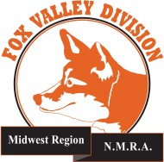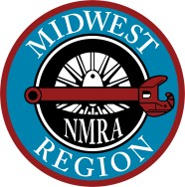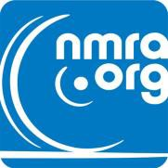

© 2023 by the Fox Valley Division of the NMRA, Inc.
If you receive this newsletter you live in the Midwest Region, Fox Valley Division of the National Model Railroad Association (NMRA). The Fox Valley Division (FVD) includes all of Lake and McHenry, as well as parts of Cook and Kane Counties in northeast Illinois. About 180 members of varied ages and modeling ability belong to the FVD. Most modeling scales are represented in our division.
Subscriptions to the Semaphore newsletters are free. Membership in the division is available through the NMRA at: https://www.nmra.org/
Monthly FVD meetings run September through May in-person and online via Zoom. Each meeting features a clinic, model contest, and

