MONTHLY NEWSLETTER OF THE FOX VALLEY DIVISION, NMRA

The Semaphore

F E B R U A R Y 2 0 2 4

Metra Fare Changes
Effective
February 1
Metra is revising its fare structure and fare options effective Feb.
1. The biggest changes are eliminating the 10-

Letting the Kids Drive
Getting the next generation involved in the hobby
In this issue
L’Obsession P.3 Next meeting P.3 Upcoming Events P.4 Contest Calendar P.5 Contact Info P.5

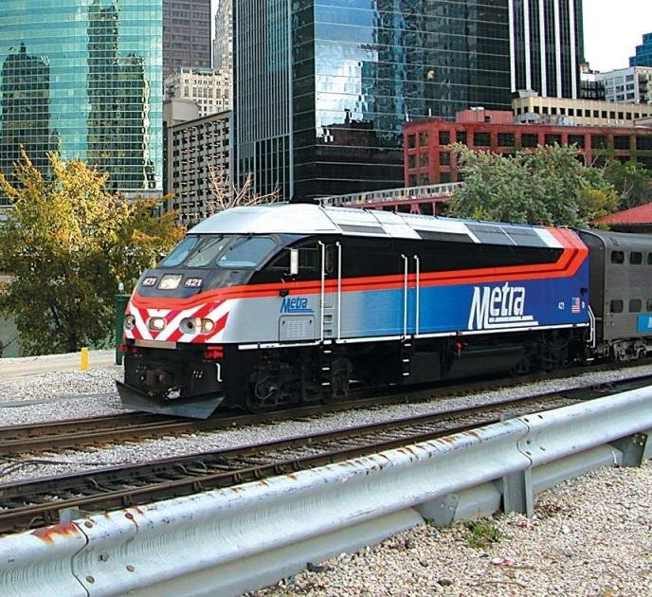
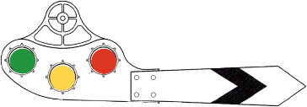
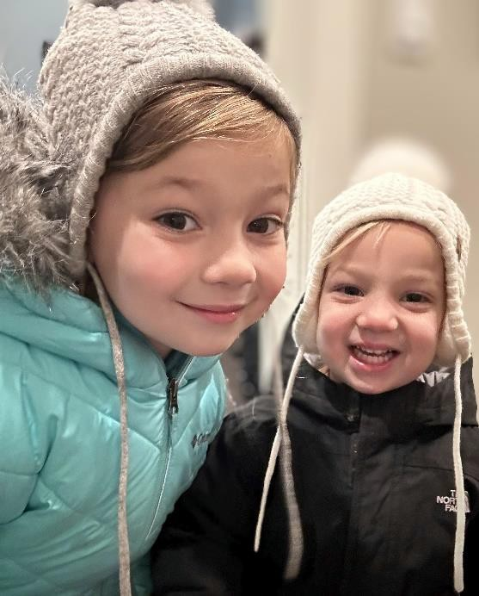
Ride Ticket as a fare
option and reducing the number of fare zones to 4 from 10. All downtown stations are in the new Zone 1, with the remaining stations assigned to Zones 2 through 4. In addition, effective Feb. 1, tickets will no longer be sold at ticket windows; you may buy them from vending machines or the Ventra app. (BSNF windows closed on Jan. 8.)
For full details about Metra fare changes, including the new fare zone map, please see Metra
I’ve only been part of the model railroad scene for a short while, but the ongoing concern about declining hobbyist participation and a lack of younger members has been persistent. It has ramped up recently with announcements of the closure of a couple long-running stores on both sides of the pond (Model Train Stuff and Hatton’s). Are model railroads in trouble? I don’t think so. I think we just like worrying out loud. Misery loves company after all.
I do want to address the concern of getting younger people involved in the hobby. I’ve got a couple granddaughters of impressionable age whom I believe will make great test subjects. I want to discover if it’s possible to plant the seeds for a future modeler. Or see if we even have a present modeler.
The approach is simple: do small modeling projects with the girls and see what sparks their imagination. They explore, and I follow to see where it leads. And clean up the mess. At this age the journey seems to be less about trains than it is about the adventures that occur, with railroads being
1
a background to the story.
They're in a good environment to pick up on train vibes. Literally. Living in sight of the Union Pacific Northwest line, they sit on the front porch on warm evenings and see, hear, and feel the trains rumbling past, with the old house rocking a little each time one passes.

Future modeler test subjects A & B; a.k.a., Ellie & Ada. Even without their thinking hats, they’re much smarter than grandpa.

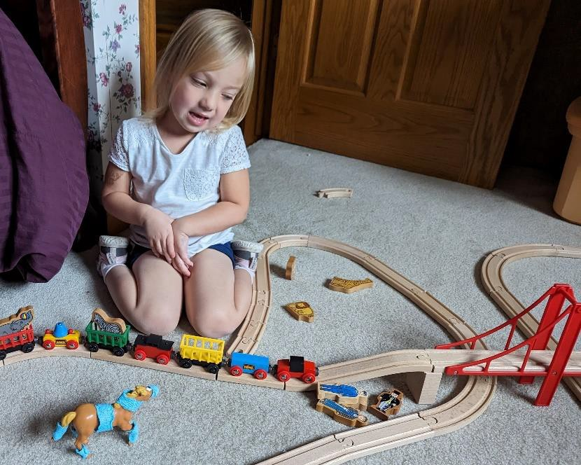
 Railroad Operations, preschool version

At home they've accumulated a large collection of Brio track and accessories, which is usually spread out to cover the living room floor. When they come to visit, they pull out our old set, which includes a variety of circus animals.
Running trains around a flat track was a bit boring, so they snatched a feather comforter off the bed to model mountainous terrain. While the cars tend to fall off the steep slope, it’s given them valuable insight into the hazards of unstable ground and the need for reliable connections between track sections.
On the modeling side, Ellie has been assisting on the construction of an experimental layout, which will have a water feature.
She’s painted several riverbed colors to see which one looks best when covered with water.
Left: Ada explains how to save animals that tangle with a high-speed freight. The heavily bandaged horse knows the drill.

Key findings so far:
- The girls enjoy their own version of railroad “operations.” When a toy animal is hit by a toy train the suffering creature is transported for surgery, bandaged, and sent back to the field. Voila: operations. I'm assigned ER support, standing by with sticky surgical tape to bind wounds on any creature that tangles with an unstoppable locomotive. We haven’t discussed realism, so the subject of fake blood and getting ketchup stains out of carpet hasn’t yet come up.
- Adult consensus: when walking barefoot, Brio tracks are less painful than Lego bricks.
- Ellie was a bit miffed to discover that model railroading does not work like a demolition derby. At this age the girls’ only interest in operating scale electric trains is cranking the throttle to 11. Belatedly, locos have been programmed for a maximum throttle setting to be half engine speed.
Going forward, imaginative play with wooden trains, animals, and hospital operations will continue. I’ve got a battery-powered loco that’ll haul the circus from winter zoo to summer performances. Ellie’s much more interested in landscapes and structures, so that’s where we’ll head next. If there’s anything newsworthy to report -- or if there’s nothing else to publish -– you’ll read it here next.

2
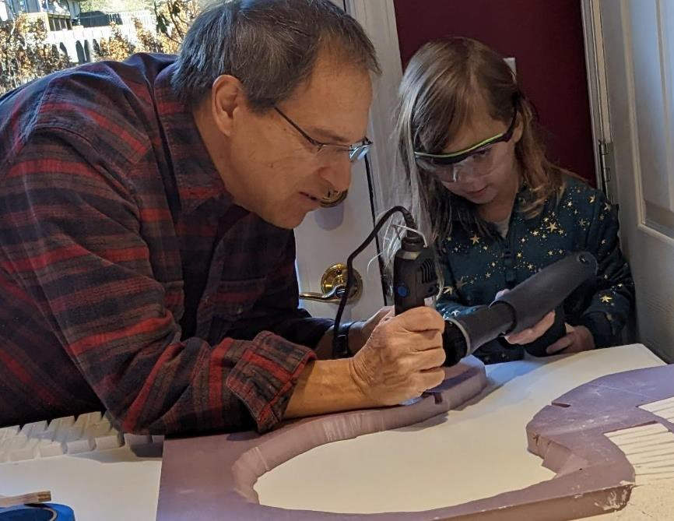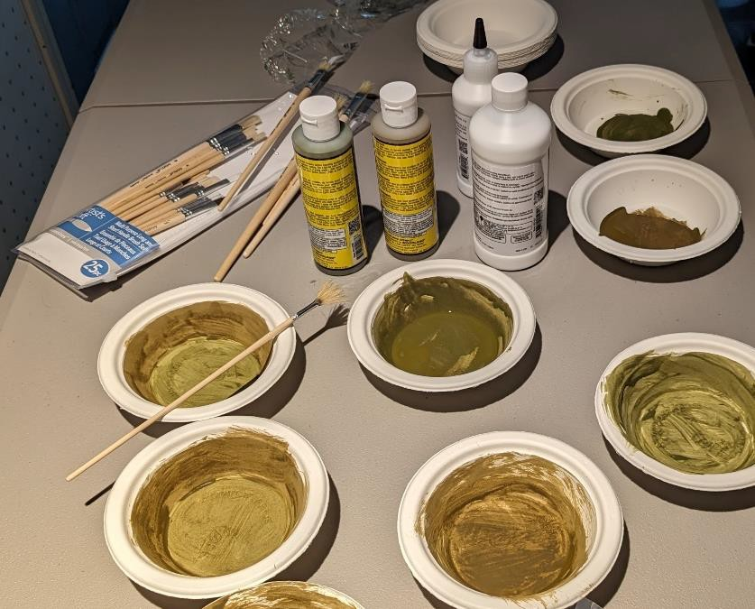

 L’Obsession Crazy about the CTA? This board’s for you
Are you an L fan? Get this: an electronic map showing the real-time location of trains in transit to every station. Tri- color LEDs shine on a circuit board, updated 60x/minute, silver traces showing the routes, with "a representation of Lake Michigan and the Chicago River using a contrasting copper pour beneath the green solder resist of the board," according to the company website. Includes a fiberboard stand, power supply and cable. Requires a Wi-Fi connection. $279 at traintrackr. Train and weather maps are available in other cities in the US and UK.

Set this up on your bedroom shelf, turn off the lights and watch the flow. And get your significant other a sleep mask.

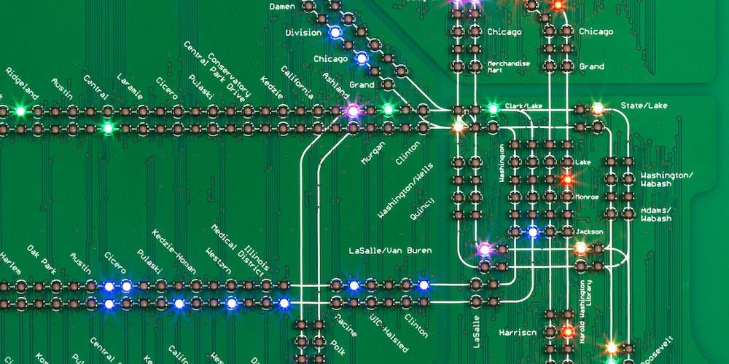
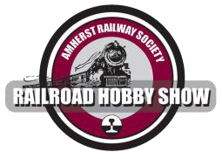
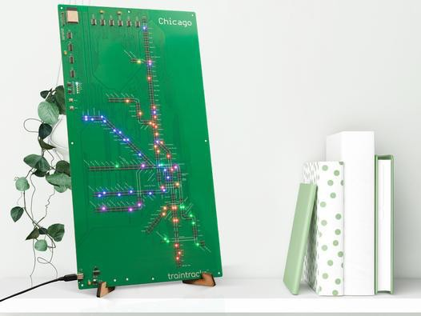

Amherst Show Highlights

Didn’t make it to the annual show out east? Well, if you’re just sitting there in front of the computer, you might as well watch these videos.

YouTube Amhurst Listing. Interesting episodes:
- Live Show Tour, Human[c]ity Junction. 2h 47m
- Manufacturers and Vendors, My Life’s Tracks, 25m

Show Layouts, John Reall, 18m
- What’s New in Model Railroading, Nsmodeler24, 20m
- She Dragged Me Here!! Real Toy Trains, 23m Next show is January 25 & 26, 2025.
3
Next FVD Meeting
- February 18, 2:00
- Glenview Public Library & Zoom
- Clinic: Shooting the Diesel That Did It
- Model Achievement: Up to 3 weathered cars or structures
- Show & Tell

Upcoming Events

Monthly FVD Meetings
Held the third Sunday of every month at either the Glenview Public Library or the Gary Morava Recreation Center, the meetings are an opportunity to share information, either in-person or on Zoom. Here is the meeting schedule through the end of the year. See the full schedule on the FVD website.
When | Where
2/18/24 2:00-4:00 PM | Glenview Public Library and Zoom
3/17/24 2:00-4:00 PM | Glenview Public Library and Zoom

Midwest Regional Events
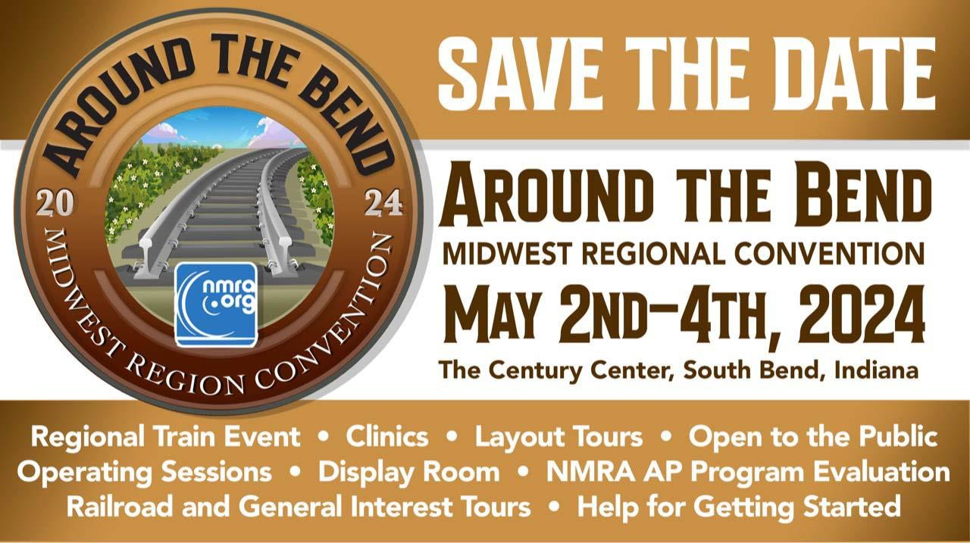
Around the Bend Convention Information

Train Shows
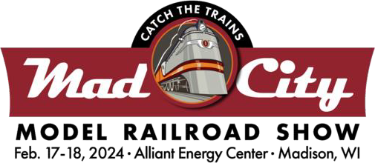
Delavan Train Show: Fri/Sat March 9, 9 – 4, March 10, 10 – 4. Begin the show at the Delavan American Legion Hall where you will receive your map and train "ticket" to be punched at each location you visit. 111 S. 2nd St., Delavan WI
Great Midwest Train Shows: monthly at the DuPage Event Center and Fairgrounds in Wheaton. The traveling show will be in East Moline, IL March 16-17. Information on both shows can be found on Trainshow.com.

4

Division Meeting Date | Contest
February 18 | Up to 3 Weathered Cars or Structures
March 17 | Up to 3 Steam Locomotives
April 21 | Up to 3 Refrigerated Billboard Cars
May 19 | Up to 3 Freight Cars with an Open Load

About the Fox Valley Division
Contest rules
Future contests be held in person at the meet. There will be no photographic entries. All entries will ONLY be displayed at the meet.
Contest Calendar
Superintendent: Michael Hirvela
Board of Directors
Asst. Superintendent: Denis Zamirowski
Paymaster: Richard Sieben Chief Clerk: Richard Hoker Achievements & Contests: Jim
Landwehr
Clinics & Programs: Gary Saxton

Membership Promotions: Michael Hirvela
Membership Services: Erich Abens
Public Relations & Social Media: Keith Dart
Webmaster: Jim Osborn, MMR®
Semaphore Editor: Chris Mattimiro Contact any board member here.

About the Semaphore
The Semaphore is published by the Fox Valley Division of the Midwest Region of the NMRA, a registered 501(c)(7) not-for-profit Illinois corporation.

Staff:
information of interest to the membership. Outings, layout tours, and operating sessions may also be held.
We encourage you to take advantage of all the FVD has to offer. We are here to answer your questions, help improve your modeling, and help you better enjoy the great hobby of model railroading. Visit us on the web!
Mailing Address:
Fox Valley Division PO Box 1535
Arlington Heights IL 60005-1535
Website:
https://foxvalleydivision.org/
Facebook:
https://www.facebook.com/fvdnmra/
Editor: Chris Mattimiro Assistant Editor: Michael Hirvela Assistant Editor: Jim Osborn

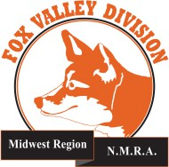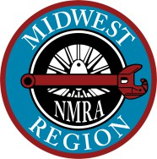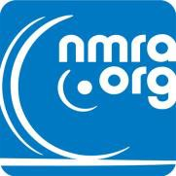

© 2024 by the Fox Valley Division of the NMRA, Inc.
5
If you receive this newsletter you live in the Midwest Region, Fox Valley Division of the National Model Railroad Association (NMRA). The Fox Valley Division (FVD) includes all of Lake and McHenry, as well as parts of Cook and Kane Counties in northeast Illinois. About 180 members of varied ages and modeling ability belong to the FVD. Most modeling scales are represented in our division.
Subscriptions to the Semaphore newsletters are free. Membership in the division is available through the NMRA at: https://www.nmra.org/
Monthly FVD meetings run September through May in-person and online via Zoom. Each meeting features a clinic, model contest, and

